
DST52A Depth Transducer
General
The DST52A is a Long Stem Bronze Thru-hull transducer for use on sailboats and powerboats that require a thru-hull transducer in a location with a deadrise angle of 15° or more.
Specifications
Frequency | 200 kHz
Dimensions | (see figure 1)
Shaft diameter | ¾”
Shaft length | 4 ½”
Cable length | 30’
Cable connector | RCA Phono Plug

Accessories
EX345D | 15’ depth extension cable
FB52 | Fairing Block

Note: The DST52A requires the use of a fairing block for installation

Note: Only one extension cable may be used for a total cable length of 45’.
It is not recommended to cut and splice transducer cable because performance may be affected.

Please refer to the Standard Horizon Transducer Installation Guide for detailed installation information.

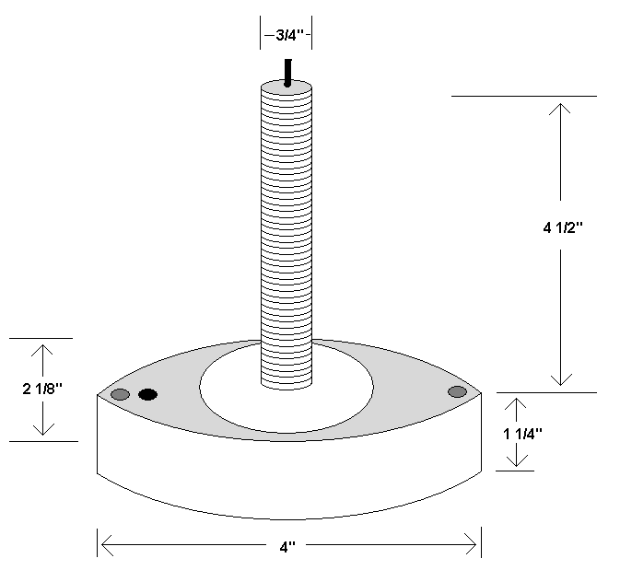
Figure 1. DST52A Depth Transducer

