
DST155 Depth Transducer
General
The DST155 is a low cost, nylon, in-hull transducer for use on sailboats and powerboats that have a solid fiberglass hull.
Specifications
Frequency | 200 kHz
Dimensions | (see figure 1)
Shaft diameter | 2 ¾”
Shaft length | 2 1/8”
Transducer housing | 13° deadrise
Cable length | 30’
Cable connector | RCA Phono Plug

Accessories
EX345D | 15’ depth extension cable

Note: Only one extension cable may be used for a total cable length of 45’.
It is not recommended to cut and splice transducer cable because performance may be affected.

Please refer to the Standard Horizon Transducer Installation Guide for detailed installation information.

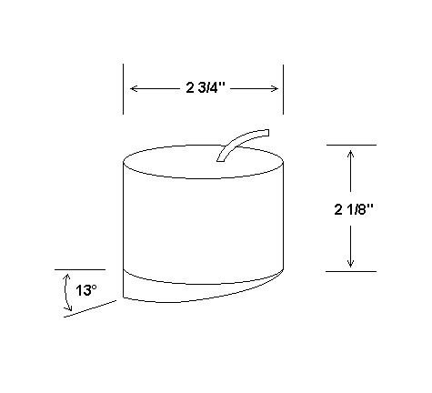
Figure 1. DST155 Depth Transducer

